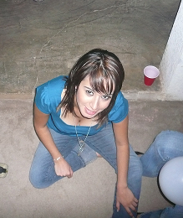

Hi everyone! My name is Nitzia Gradias. I am 18 years old. I was born in Cananea Sonora, but I nowadays I am living in Hermosillo. I am studying International Businesses at the UVM. I really like and enjoy my career. I believe I am having a great start and hope to continue this way. During the afternoons, I work at a bilingual school as an english teacher. I teach children and adutls. As a hobby I like to go to the gym and chat with my friends. Whenever I have a free time, I like to go out with my friends and have a fun time.

On this assignment, I was the one who created the hotmail account and the website. I also provided all the information to my team and they were the ones who uploaded their own information. I also did the Case Study Essay.

